William Morrow
10 East 53rd Street, New York, NY 10022

Publicity Contact: Sharyn Rosenblum, Sr. Director of Media Relations / 212-207-7470 / sharyn.rosenblum@harpercollins.com

THE NEW YORK TIMES COLUMNIST AND BEST-SELLING AUTHOR OF THE COUNCIL OF DADS TURNS TO THE MOST CREATIVE MINDS IN THE WORLD TO DEVELOP A MODERN PLAYBOOK WITH MORE THAN 200 NEW IDEAS FOR HIS OWN FAMILY—AND YOURS.

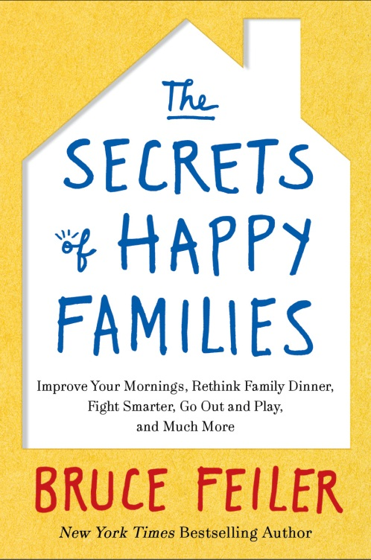

“The last few years have seen an outpouring of books, articles, and magazine covers wrangling over the issue of what’s the proper way to raise children. Be strict like the Chinese; no, be lax like the French; spank ’em like they did in the good ’ol days of the good ’ol U.S. of A…. The authors of those books have an ideology they want to promote. I don’t. I don’t have a country I’m trying to emulate. I don’t have a mascot. I have a question: What do happy families do right and how can the rest of us learn to make our families happier?”--Bruce Feiler, The Secrets of Happy Families

Caught between aging parents and growing children, New York Times columnist and best-selling author Bruce Feiler, felt the same pressures many of us feel. But when his annual family vacation erupted into arguments over texting, whining, and manners, he knew the old rules of family life weren’t working anymore. He needed a new playbook for modern-day families, something to counteract the chaos of the digital age.

Rather than turning to the traditional family experts, Feiler used his experience as an investigative reporter to seek new sources—the most creative minds in business, sports, technology, television and the military. He asked them what cutting-edge techniques from their professional lives they used with their own families. Then, with the sense of humor and adventure that his readers have come to love, Feiler took those ideas home and test drove them with his own wife and kids. THE SECRETS OF HAPPY FAMILIES (William Morrow; ISBN 9780061778766; On-Sale: February 19, 2013; Price: $25.99) recounts Feiler’s terrifically funny and fruitful quest, with over 200 new ideas to make contemporary family life more functional, more meaningful, and, best of all, more fun.

Many of the ideas Feiler encountered ran counter to age-old wisdom: Let your kids pick their punishments. Don’t worry about family dinner. Ditch date night. Scrap the sex talk. And it’s no wonder: Feiler spoke to people who don’t just think outside the box, they live outside the box, and their families are happier for it. Feiler, along with his wife, Linda, and their twin daughters, Eden and Tybee, eagerly tried out these practices, to hilarious, helpful (and at times disastrous) effect. Some of the bold new ideas they embraced include:

- LET YOUR KIDS PICK THEIR PUNISHMENTS. From Silicon Valley, Feiler learns a 21st century plan to reduce chaos and increase happiness. America’s top companies use Agile management techniques to improve effectiveness. Feiler adopts an Agile Family strategy, with morning lists and a weekly meeting to review what the family is doing right and wrong. Through these tactics, Feiler cut family stress in half within a week.
All Happy Families

Was Tolstoy right? Are all happy families alike? After starting out as a skeptic, Feiler now says there are common ingredients.

Adapt all the Time
Strict rules that follow a set script don’t work. Be flexible with everything, from chores to dinners to talking about sex. The strongest families know how to adapt and change.

Talk. A Lot
From mealtime to car rides, from money to sex, healthy families communicate effectively. They use stories to teach their kids resilience and values. They create a family narrative.

Go Out and Play
Invent games, travel, sing goofy songs, create corny traditions, go bowling, get lost, make a giant domino trail on the dining room table. Whatever makes you happy, doing it with your family will make your family happier.

- THE RIGHT WAY TO HAVE FAMILY DINNER. From a former U.S. Marine turned celebrity chef, Feiler learns to time-shift family dinner. Worry less about dining every night and more about finding time every day to be together. And from the country’s leading expert on family conversations, Feiler learns that what you talk about matters more than what you eat. He offers practical games to increase family togetherness and resilience.

- THE WARREN BUFFETT GUIDE TO SETTING AN ALLOWANCE. From the top bankers and wealth advisers in the country, Feiler learns surprising do’s and don’ts about how to set allowance, manage chores, encourage savings, and develop financial common sense in your children. It’s not as easy as it once was, and some of the old habits no longer work. Feiler emerges with a counterintuitive plan to teach families about earning, saving and spending.

- THE HARVARD HANDBOOK FOR FIGHTING SMART. From the world’s leading problem-solvers at the Harvard Negotiation Project, Feiler learned a step-by-step guide to reducing conflict with his wife and kids. Armed with unexpected tips, Feiler and his wife change where, when, and how they handle disputes – and what they do when their children bicker with each other and with their parents.

- THE LAW OF TWO WOMEN. From experts in how to have difficult conversations, Feiler learns helpful techniques in how manage aging parents, black sheep, or other problem areas in families. One fascinating lesson he learned from executives at Google: If you’re trying to make complex decisions, have more than one woman in the room. Research shows if you have only woman, she’ll act like a man, but two or more women will promote consensus.

- SCRAP THE SEX TALK. From a self-style “sex mom” on the front lines of kids and promiscuity, Feiler learns an eye-opening new strategy for helping children cope with the onslaught of sexuality in pop culture. Just having “The Talk” won’t cut it anymore; it’s a series of talks; it’s a conversation. Research shows parents (who are wimps on this topic) should start as early as 18 months.

- THE GREEN BERET GUILDE TO THE PERFECT FAMILY VACATION. From the America’s top warriors, Feiler learns how to build close-knit families through smart games, innovative competition, and creative exercises that promote cooperation and team building. From top game designers at Zynga, he learns new games to make long car rides, layovers, and family trips more fun.

Feiler set out with THE SECRETS OF HAPPY FAMILIES to answer a question: What do happy families do right and how can the rest of us learn to make our families happier? He knew better than to reduce the answer to a pat list. Instead he offers a broad array of fresh, new ideas that are changing the American family and invites readers to pick the ones most suited to them. “My hope is that if you take just one idea from each chapter in this book,” he writes, “your family will be transformed in less than a week.”

Above all, he emerges with what family life is all about: a story—an insightful, original, funny story about why families are important, why they’re so difficult to get right, and why this most maddening of human institutions is also the thing that brings us the most joy in our lives. Infused with Feiler’s trademark humor and wisdom, THE SECRETS OF HAPPY FAMILIES will help families everywhere enhance their lives, reduce their stress, and improve their stories every day.

ABOUT THE AUTHOR
BRUCE FEILER writes a column about contemporary families for the New York Times columnist and is the author of five consecutive New York Times bestsellers, including Walking the Bible, Abraham, and The Council of Dads. He is the writer/presenter of the series “Walking the Bible” and the forthcoming “Sacred Journey” on PBS, and appears frequently as a commentator on radio and television. A native of Savannah, Georgia, he lives in Brooklyn with his wife Linda Rottenburg, and their twin daughters, Tybee (l) and Eden (r).

THE SECRETS OF HAPPY FAMILIES: Improve Your Mornings, Rethink Family Dinner, Fight Smarter, Go Out and Play & Much More
By Bruce Feiler
William Morrow Nonfiction
On Sale: February 19, 2013
Price: $25.99
ISBN: 9780061778766

For more information, please visit www.brucefeiler.com

